Experiment No.: 6

Title: Performance Testing

Batch: B–1 Roll No.: 16010422234 Experiment No.: 6

Aim: To perform performance testing using JMeter.

Resources needed: Internet, Apache JMeter

Theory:
The Apache JMeter is pure Java open source software, which was first developed by Stefano Mazzocchi of the Apache Software Foundation, designed to load test functional behaviour and measure performance. You can use JMeter to analyze and measure the performance of web applications or a variety of services. Performance Testing means testing a web application against heavy load, multiple and concurrent user traffic. JMeter originally is used for testing Web Application or FTP application. Nowadays, it is used for functional tests, database server tests etc.
Apache JMeter may be used to test performance both on static and dynamic resources, Web dynamic applications. It can be used to simulate a heavy load on a server, group of servers, network or object to test its strength or to analyze overall performance under different load types.

Procedure:

- Install Java
Because JMeter is a pure Java desktop application, it requires a fully compliant JVM 6 or higher. You can download and install the latest version of Java SE Development Kit.
Link: https://www.java.com/en/download/help/windows_manual_download.xml
After installation is finished, you can use the following procedure to check whether Java JDK is installed successfully in your system
- In Window/Linux, go to Terminal
- Enter command java -version
If Java runtime environment is installed successfully, you will see the output as figure below
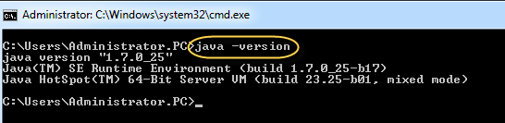
If nothing displays, please re-install Java SE runtime environment
- Download JMeter
As of this writing, the latest version of JMeter is Apache JMeter 4.0.
Link: http://jmeter.apache.org/download_jmeter.cgi
Choose the Binaries file (either zip or tgz) to download as shown in figure below
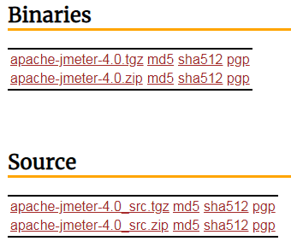

- Installation
Installation of JMeter is extremely easy and simple. You simply unzip the zip/tar file into the directory where you want JMeter to be installed. There is no tedious installation screen to deal with. Simple unzip and you are done.
Once the unzipping is done installation directory structure should look like as figure below:
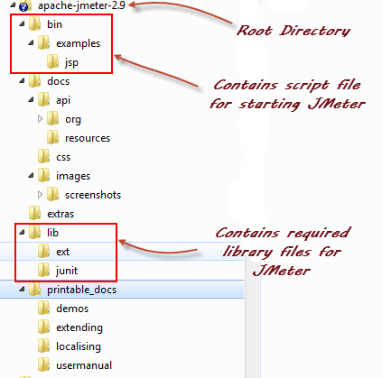

Given below is the description of the JMeter directories and its importance. JMeter directory contains many files and directory
  - /bin: Contains JMeter script file for starting JMeter
  - /docs: JMeter documentation files
  - /extras: ant related extra files
  - /lib/: Contains the required Java library for JMeter
  - /lib/ext: contains the core jar files for JMeter and the protocols
  - /lib/junit: Junit library used for JMeter
  - /printable_docs:

- Launch JMeter
You can start JMeter in two modes:
  - GUI Mode
  - Server Mode
Start JMeter in GUI Mode
If you are using Window, just run the file /bin/jmeter.bat to start JMeter in GUI mode.
Perform the following on Apache JMeter:
- Create a Performance Test Plan
- Use Constant Timer
- Use Response Assertion
- Loop Controller
- Post Processor

Results: (Document printout as per the format)

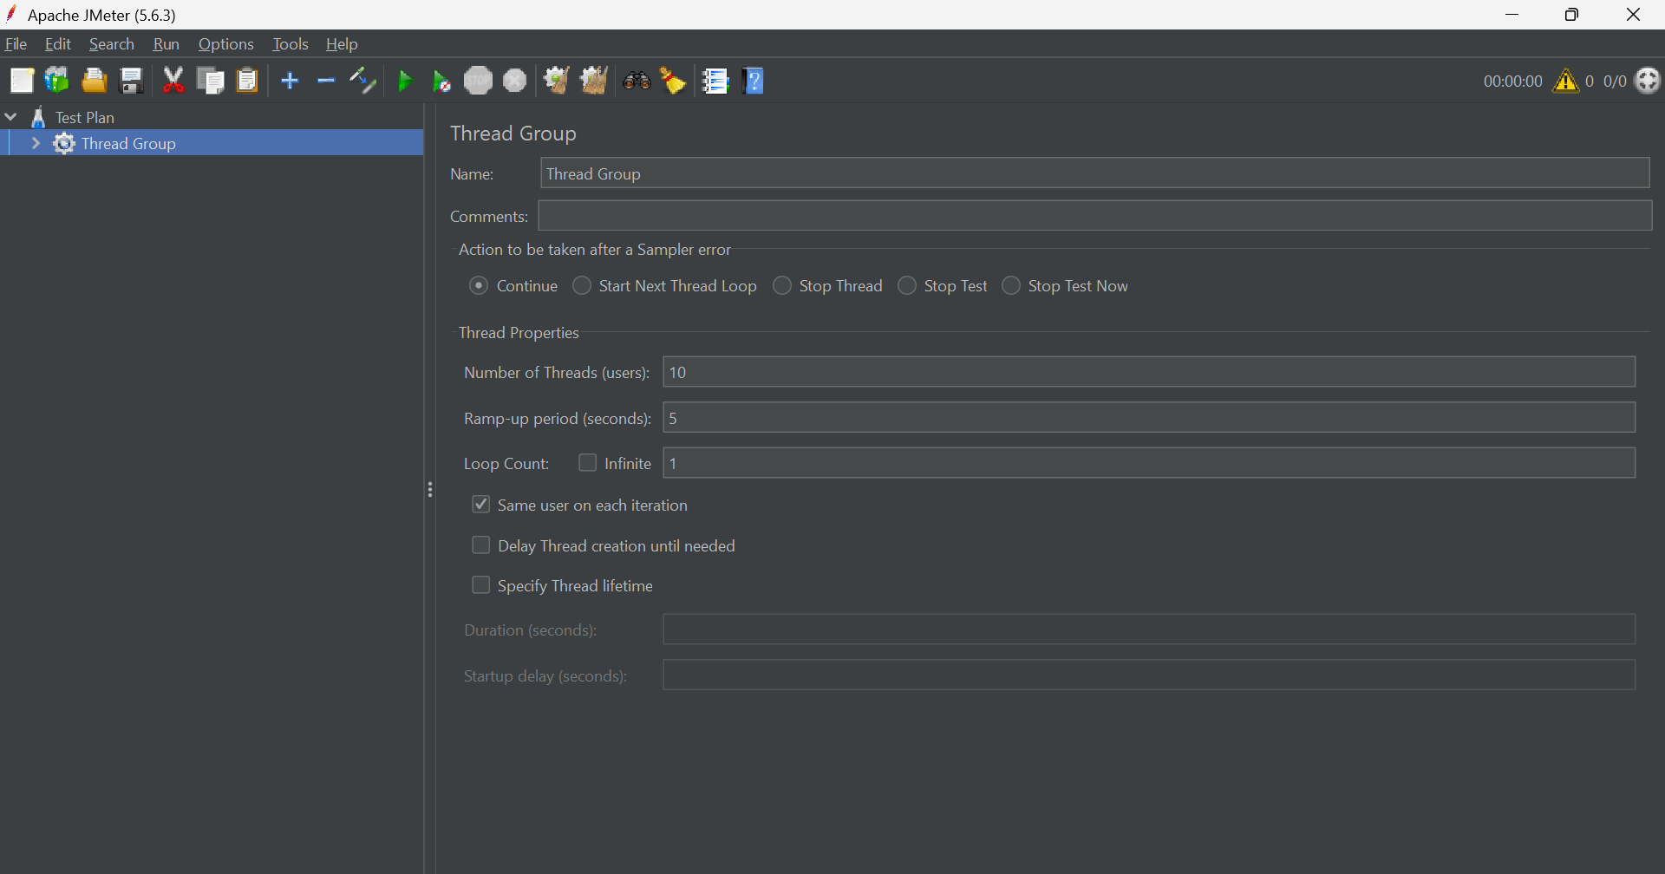
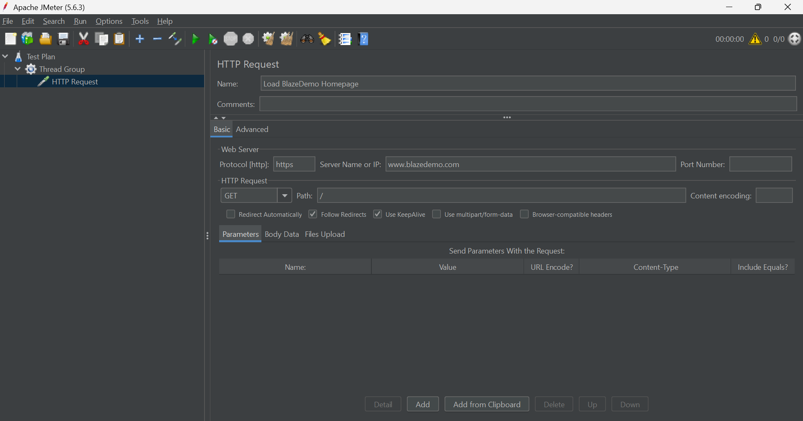

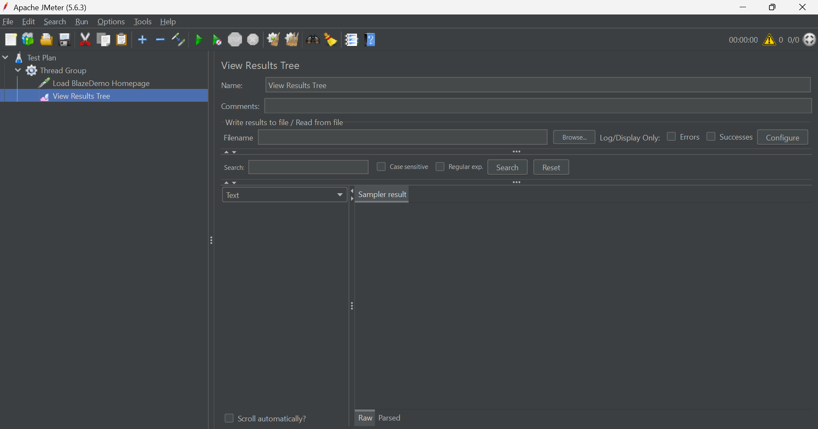
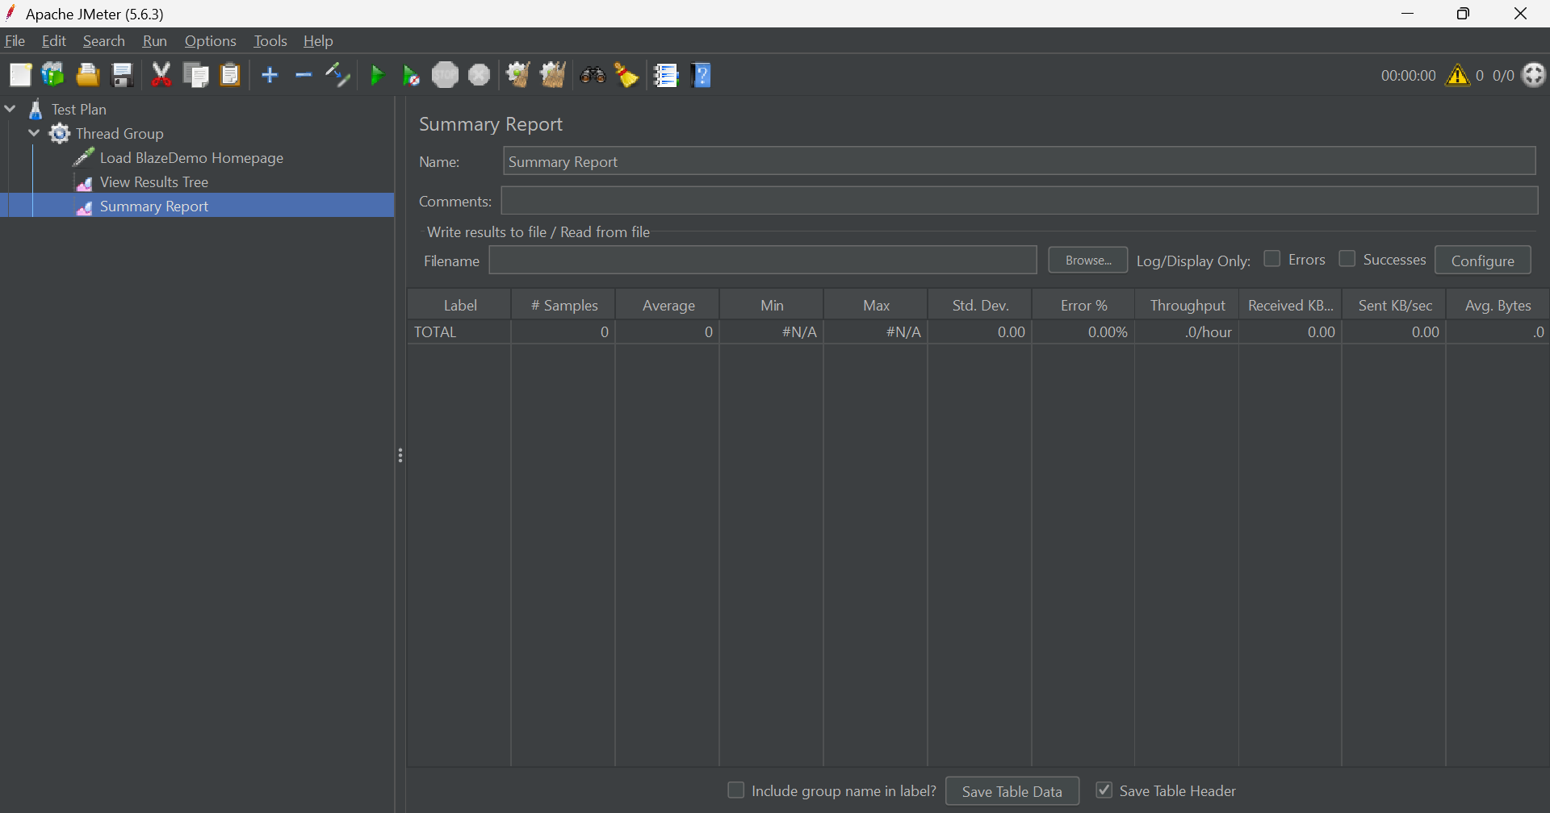

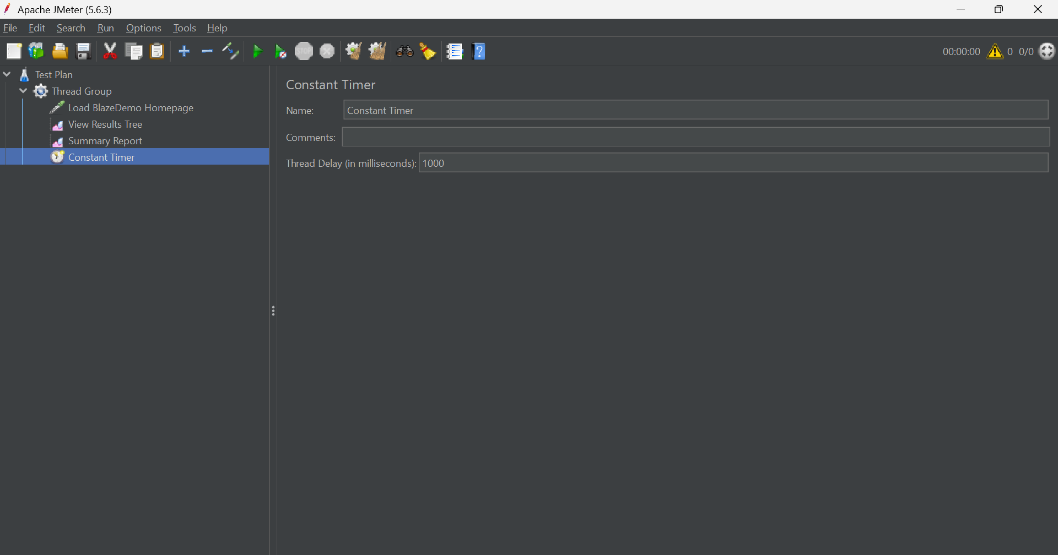
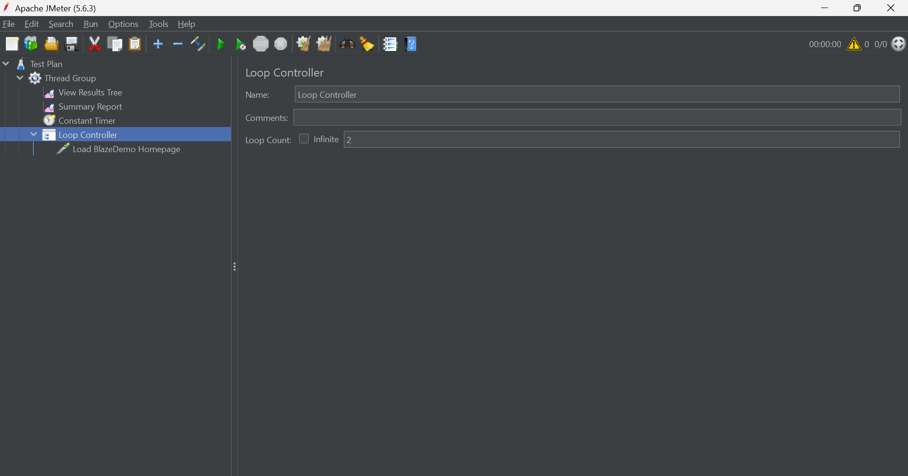

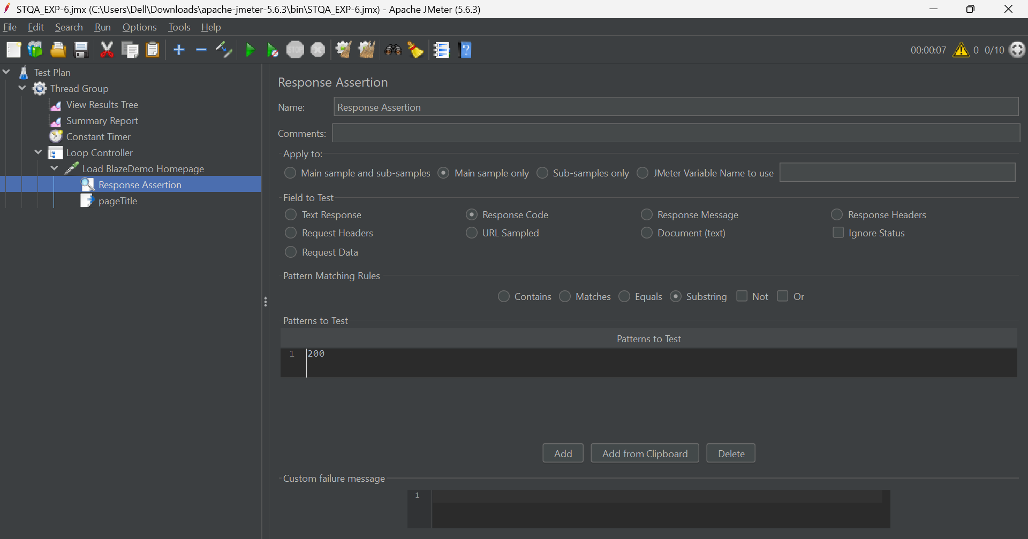
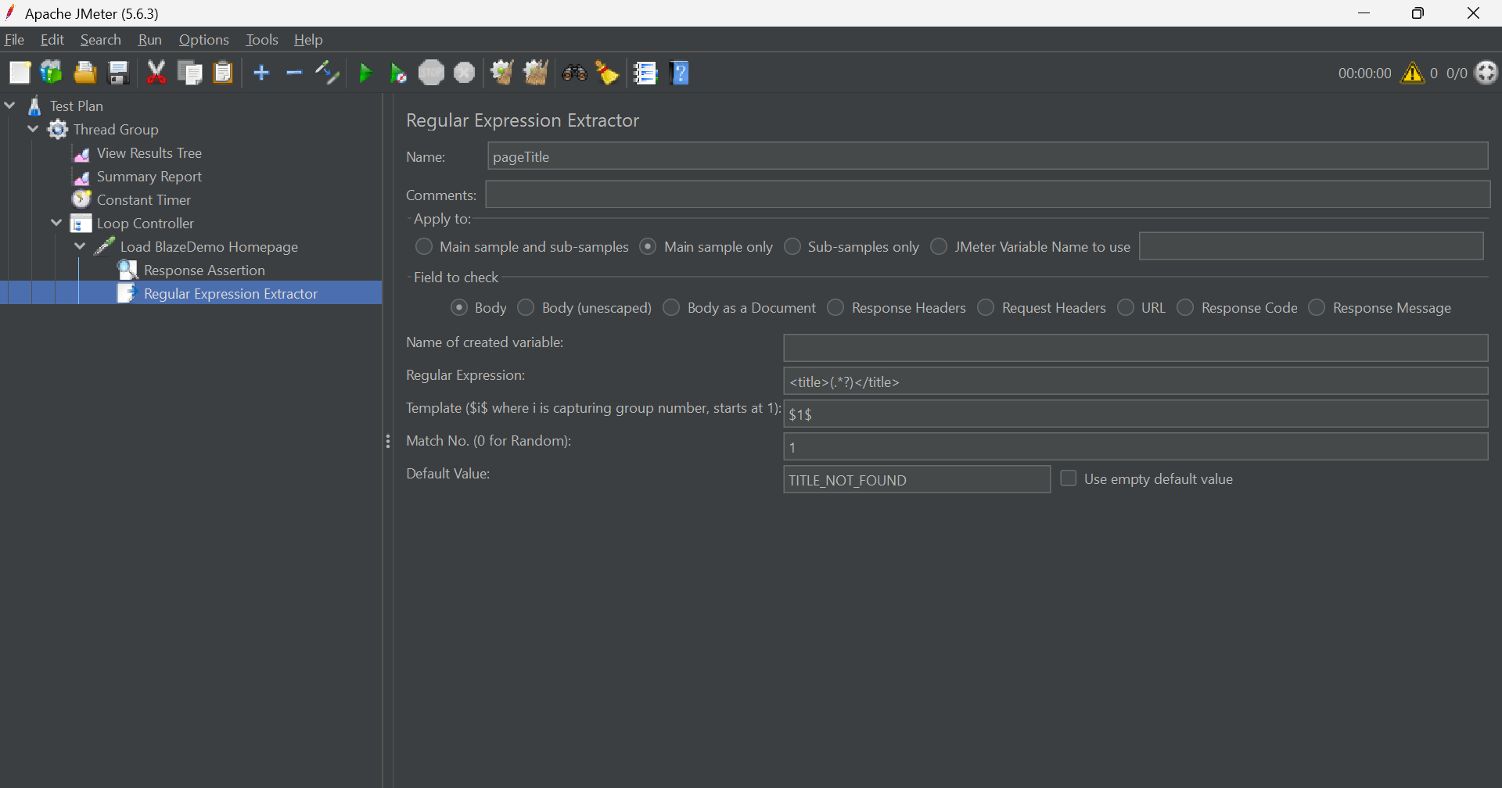

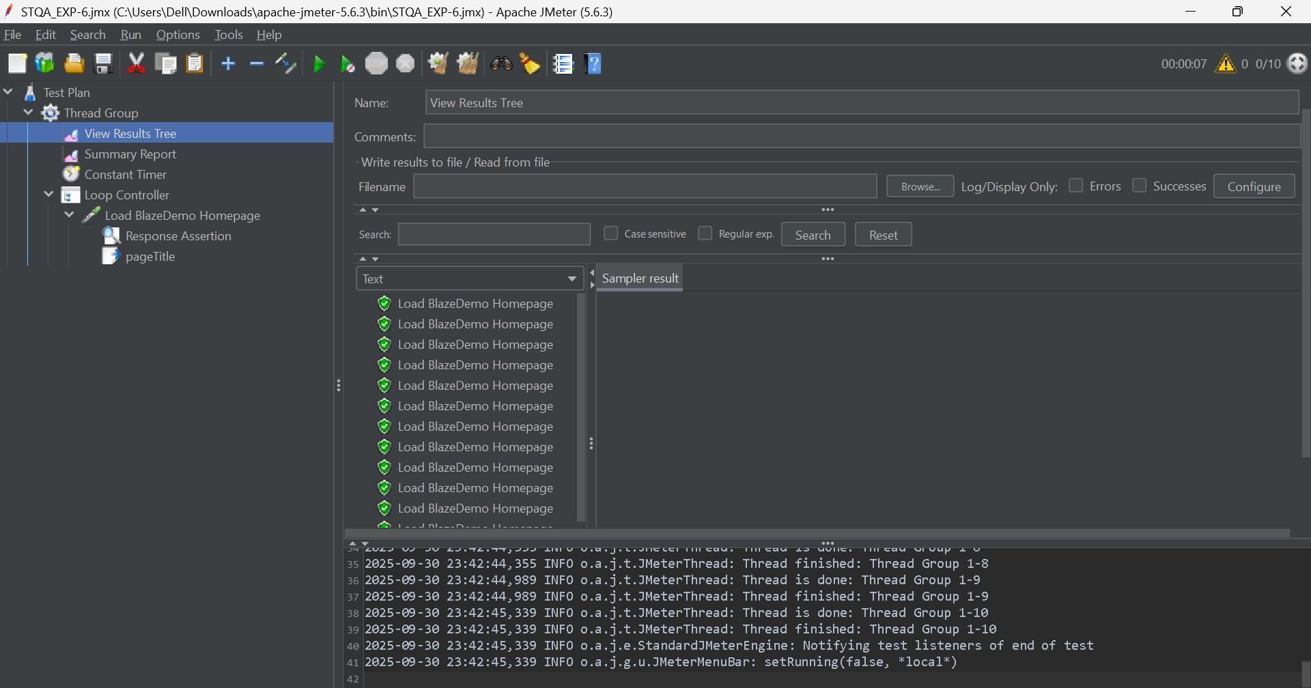
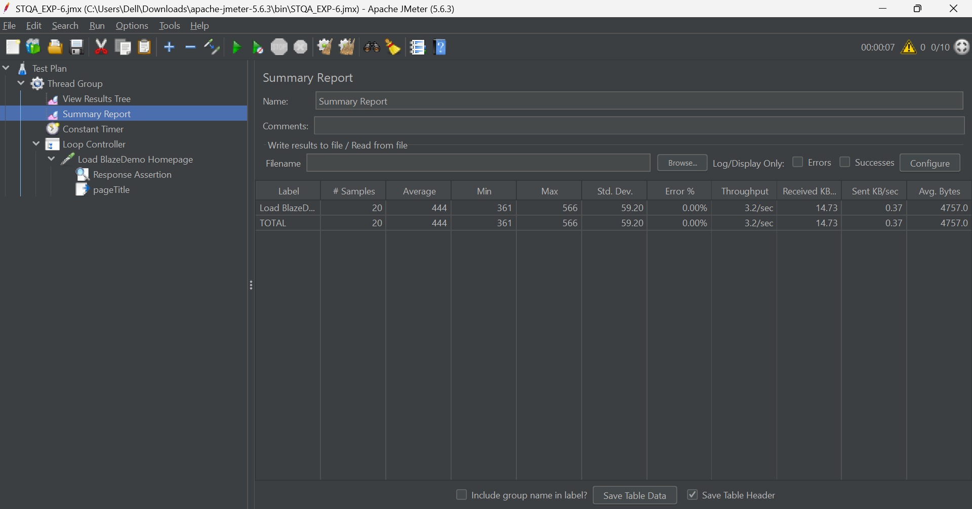

Questions:

- Why is performance testing considered highly important for web applications? Outline the performance parameters against which testing can be performed.
Ans: Performance testing is crucial for web applications because it directly impacts user satisfaction, brand reputation, and revenue. A slow or unreliable application leads to a poor user experience, causing users to abandon the site, which can result in lost sales and a damaged reputation. It ensures the application is:
- Speedy and Responsive: Users expect fast load times.
- Scalable: The application can handle a growing number of users or sudden traffic spikes without crashing.
- Stable: The application is reliable under the expected user load.
Key performance parameters include:
- Response Time: The total time from a user sending a request until they receive the full response.
- Throughput: The number of requests the application can handle per unit of time (e.g., requests per second).
- Latency: The time it takes for the first byte of the response to be delivered after a request is sent.
- Error Rate: The percentage of requests that result in an error compared to the total number of requests.
- CPU Utilization: The percentage of CPU time used to process requests.
- Memory Utilization: The amount of memory used by the application while under load.

- What are the major challenges in performance testing?
Ans: The major challenges in performance testing include:
- Realistic Test Environment: Creating a test environment that perfectly mimics the live production environment is often complex and expensive.
- Simulating User Behavior: Accurately simulating how real users interact with the application, including their navigation paths and usage patterns, can be difficult.
- Identifying Bottlenecks: Pinpointing the exact root cause of a performance issue (e.g., database query, network latency, inefficient code) can be a significant challenge.
- Tool Expertise: Performance testing tools like JMeter are powerful but require specific knowledge and skills to be used effectively.
- Managing Test Data: Generating and maintaining large volumes of realistic and secure data for testing can be complicated.

Outcomes: CO3 – Apply recent automation tools for testing software.

Conclusion: (Conclusion to be based on outcomes)
This experiment successfully demonstrated the use of Apache JMeter to conduct performance testing on a web application. By creating a test plan, adding thread groups to simulate user load, and using elements like timers and assertions, we were able to measure and analyze key performance metrics. This practical application of JMeter fulfills the objective of applying recent automation tools for software testing, providing valuable insights into application behavior under stress and ensuring a better end-user experience.

Grade: AA / AB / BB / BC / CC / CD / DD

Signature of faculty in-charge with date

Reference Websites:
- https://www.guru99.com/jmeter-performance-testing.html
- https://dzone.com/articles/jmeter-performance-and-load-testing
- https://jmeter.apache.org/

